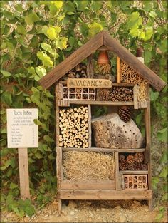
Create a multi-story hotel that's full of all sorts of natural materials.
Create your own minibeast hotel!
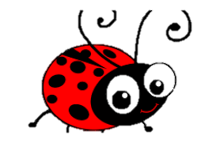
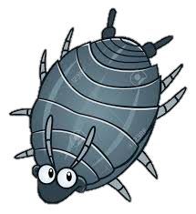
Once built, monitor what creatures visit your hotel, keep a diary where you can draw a picture of what you find, or be more detailed.
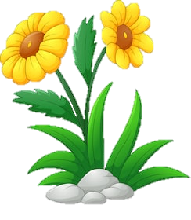
What have you identified?
How many legs does it have?
Does it have wings?
How many minibeasts are there altogether?

You can choose any of the following:
- Old wooden pallets
- Strips of wood
- Straw
- Dry leaves
- Woodchips
- Old terracotta pots
- Bricks, preferably those with holes through them
- Old logs
- Bark
- Pine cones
- Sand
- Soil
- Dead hollow stems cut from shrubs and herbaceous plants
- Whatever else you can find - preferably natural materials

Method:
- Choose a suitable site. It needs to be level and the ground firm
- Fill the gaps. The idea is to provide all sorts of different nooks and crannies, crevices, tunnels and cosy beds
- Add a 'roof'. When you think you've gone high enough, making sure the stack remains stable, put a roof on to keep it relatively dry. Use old roof tiles or some old planks.
- If possible, surround your hotel with nectar-rich flowers – essential food for butterflies, bees and other pollinating insects.
- Give your hotel a creative sign so the insects know its open!
