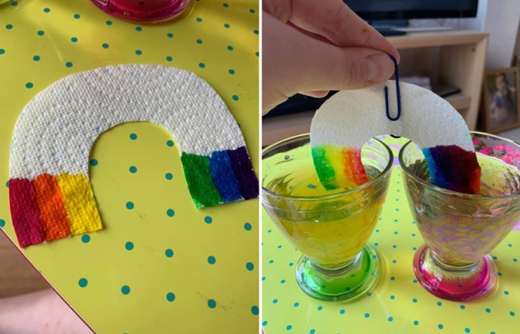
RAINBOW
SCIENCE

Grow a rainbow for our NHS
and explore the process plants
use to absorb water

This scientific process is called the capillary action which is an action that happens when a liquid moves up through a tube or spongy, solid material. Just like how plants use capillary action to bring water up the roots and stems to the rest of the plant.

For this science experiment you will need:
- Kitchen roll
- felt tip pens
- 2 small bowls of water
- a paper clip

What to do:
- Cut the kitchen roll into the shape of a rainbow
- At the ends of the kitchen roll use the felt tip pens to colour the rainbow colours
- Attach the paper clip to the top of the rainbow
- Add water to the 2 bowls
- Hold the rainbow and submerge both ends in the water.
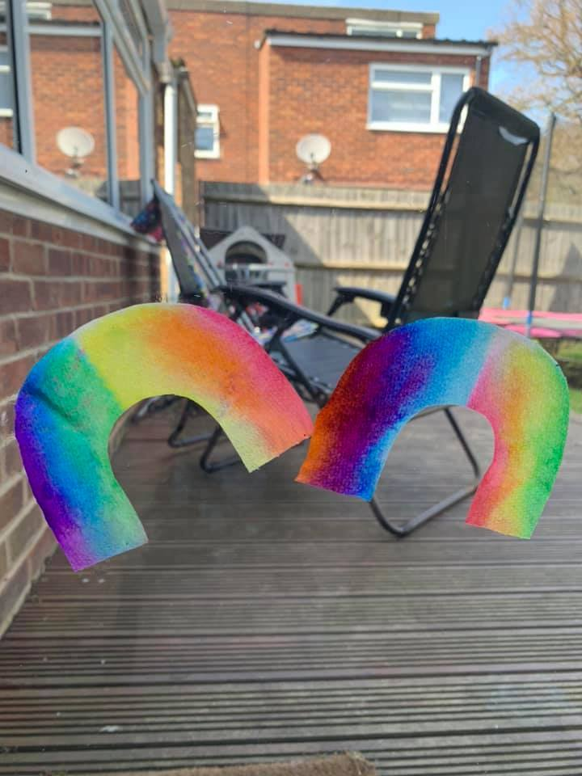
- Watch your rainbow grow!

